**Porthole Mirror in Antique Gold**

**Price: $265**

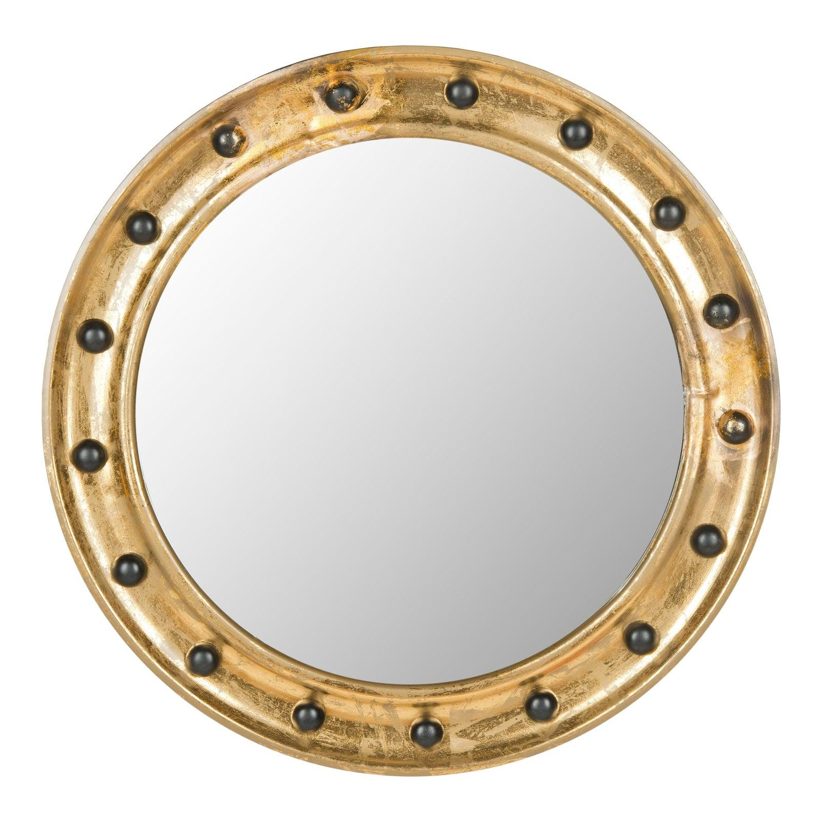

* CATEGORIES

Dressing Room

* MATERIALS

Decorative Mirrors

* SHAPE

Circle

* BRAND

Inax